What components do we have for a domain model: a domain model here will only include real world objects so
Player 1, player 2 , a game and a board
Player
- Human participant
Game
- Controls rules, turns, win conditions
Board
- Stores game state (X/O grid)

Use Case 1: Start / Join a Game
This use case captures how two separate players hook into a single game instance to get it running.
Sequence Flow:
- Step 1: Player 1 creates a new game session.
- Step 2: Player 2 joins that same session.
- Step 3: The Game initializes the empty Board.
- Step 4: The Game decides who goes first (e.g., Player 1) and notifies them.

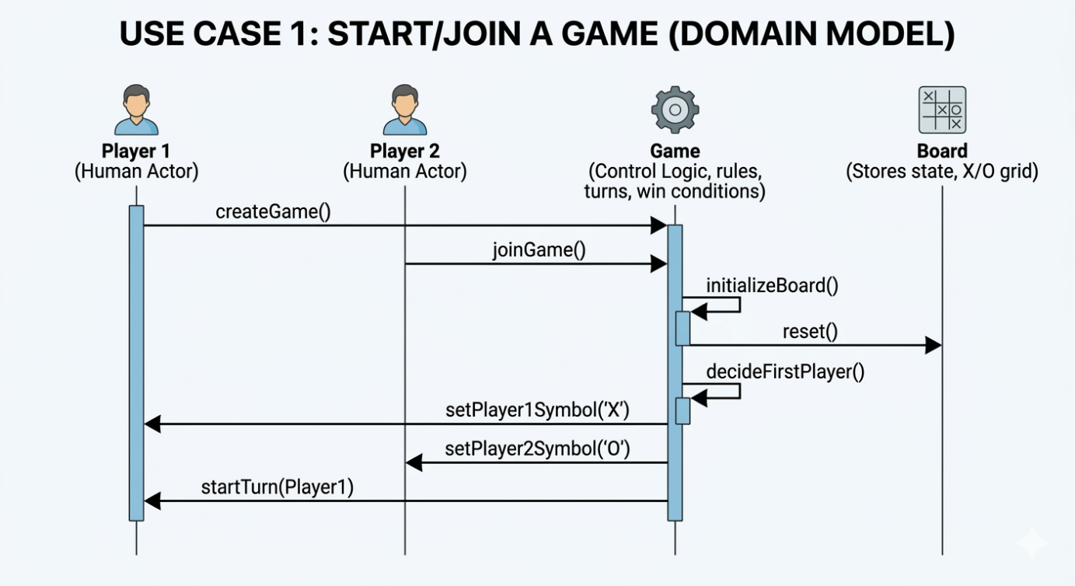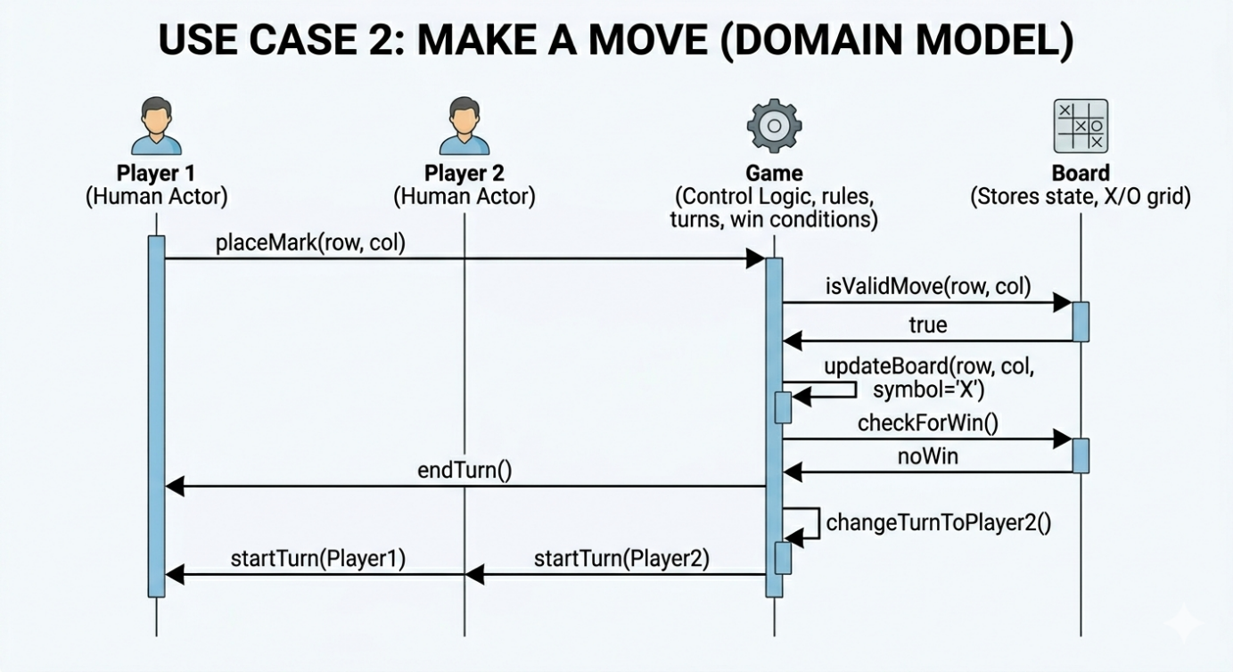
Use Case 2: Make a Move (Standard Turn)
This use case captures the heart of the game loop: a player choosing a spot, the game validating the rules, updating the board, checking for a win, and swapping turns.
Sequence Flow:
- Step 1: Player 1 places their token (X) at a specific coordinate.
- Step 2: Game checks its rules to see if that spot is valid.
- Step 3: Game tells Board to update its grid state.
- Step 4: Game checks the Board for a win/draw condition.
- Step 5: Game notifies Player 2 that it is now their turn.

